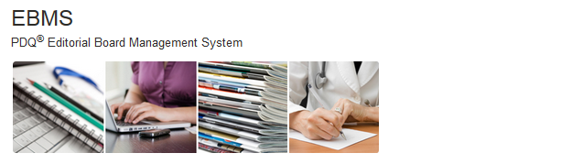
GO TO LOGIN PAGE

You will need either a Google account or an NIH account to log into this system. Click GO TO LOGIN PAGE above to login to the system. On the login page, select “HHS Login” if you have an NIH account and “Social Login/Open ID” if you have a Google account.
If you are a new user or have any problems logging in, please contact your PDQ Board manager.

